|  |  |
| --- | --- |
| **HOW TO FILE CIVIL TRIAL EXHIBITS (Attorney instructions)** | 7/23/2024 |

**REFERENCE**

Local Rule 83E(d) – Exhibits

**Custody with Clerk of Court.** All exhibits offered or received into evidence at a trial or hearing must be electronically filed via ECF by the party offering the exhibit. If an exhibit cannot be electronically filed (such as physical evidence) it must be left in the custody of the Clerk of Court, except as provided in sections (e) and (f) of this rule. Until judgment in a case becomes final, exhibits may not be taken from the custody of the Clerk of Court, except upon order of the court and the execution of a receipt.

**HOW TO FILE**

Generally, only one docket entry should be used for filing all exhibits admitted in trial or at a hearing and one docket entry should be used for filing all exhibits offered but not admitted in trial or at a hearing. However, in instances where you need to file both sealed and unsealed exhibits, you will create one entry for sealed exhibits and one entry for unsealed exhibits.

**UNSEALED TRIAL EXHIBITS**

Only one entry should be used for filing all **unsealed exhibits**. DO NOT create an individual docket entry for each exhibit.

1. Go to the Civil tab
   * Go to Other Filings
     + Notices
     + Select: Notice of Filing of Exhibit(s)
     + Next

* Enter the case number
* Next
* Next

1. Select from the choices on the below screen:

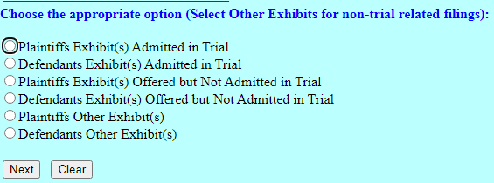

* Next

1. On the document attachment screen:

* Main Document – attach the Notice of Filing Exhibit form you completed (located under “Attorney Info” and then the “Forms” tab)
* Each unsealed exhibit should be a separate attachment
  + Each exhibit should be properly named
  + From the Category drop down menu select “Exhibit”
  + In the Description text box type the letter/number or description of your exhibit

**DO NOT type the word “Exhibit” in the Description box** 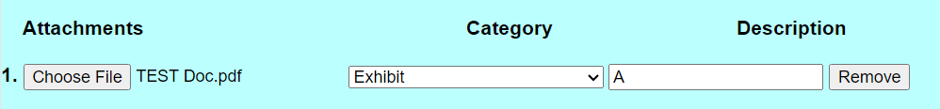

1. For exhibits delivered to the clerk’s office on a thumb drive/CD/DVD:

* A PDF place marker page should be uploaded and description added to where the exhibit is located (see example text below)

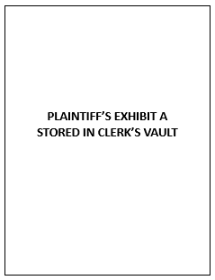 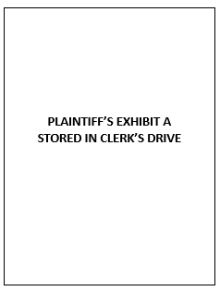 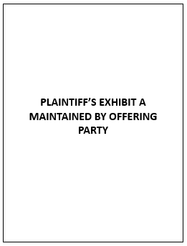

* + From the Category drop down menu select “Exhibit”
  + In the Description text box type the letter/number of your exhibit followed by one of the following:
    - “Stored on clerk’s drive”
    - “Stored in clerk’s vault”
    - “Maintained by offering party”

**DO NOT type the word “Exhibit” in the Description box**

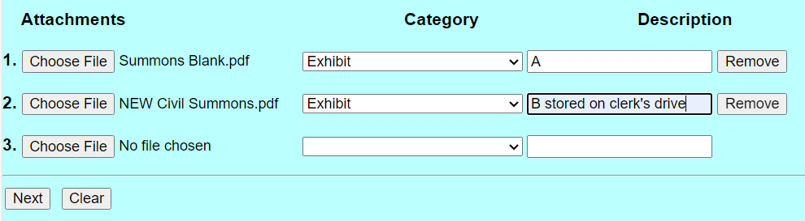

* Click Next
* Select the party filing the document
* Click Next

1. The next screen will ask if you want to link this entry to another document filed in this case. You must link this entry to the last day of trial minute entry

* Put a check in the box

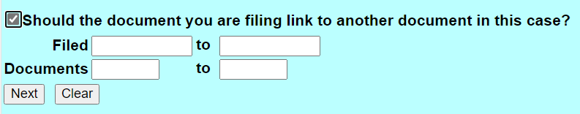

* Click Next
* The next screen will pull up the docket with the documents you can link to
  + Find the Minute Entry for the last day of the trial
  + Click the box on the left to select the entry you are linking to
  + Next
  + Next
  + Click Next to finalize your filing

**SEALED TRIAL EXHIBITS**

Only one entry should be used for filing all **sealed exhibits**. DO NOT create an individual docket entry for each exhibit.

1. Go to the Civil tab

* Go to Sealed Document – Docket Text Public
  + Select: Sealed Other Documents – Docket Text Public
    - Select: Notice of Filing of Sealed Exhibits (SEALED) AP-DTP
* Enter the case number
* Next
* Next

1. Select from the choices on the below screen:

* Next

1. On the document attachment screen:

* Main Document – attach the Notice of Filing Exhibit form you completed

(located under “Attorney Info” and then the “Forms” tab)

* Each sealed exhibit should be a separate attachment
  + Each exhibit should be properly named
  + From the Category drop down menu select “Exhibit”
  + In the Description text box type the letter/number or description of your exhibit

**DO NOT type the word “Exhibit” in the Description box**



1. For exhibits delivered to the clerk’s office on a thumb drive/CD/DVD:

* A PDF place marker page should be uploaded and description added to where the exhibit is located (see example text below)

  

* + From the Category drop down menu select “Exhibit”
  + In the Description text box type the letter/number of your exhibit followed by one of the following:
    - “Stored on clerk’s drive”
    - “Stored in clerk’s vault”
    - “Maintain by offering party”

**DO NOT type the word “Exhibit” in the Description box**

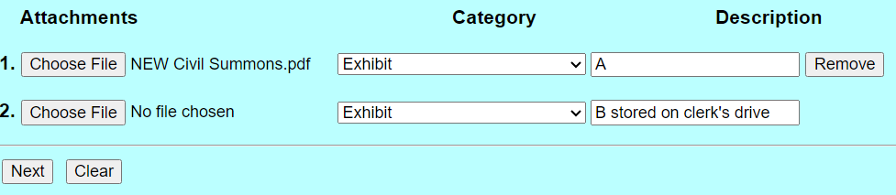

1. After all of the unsealed exhibits or place markers have been uploaded and named, click Next
2. Select the party filing the documents, click Next and click Next again.
3. The next screen allows you to select the parties that will have access to this entry. Select the appropriate parties by holding down the CTRL key and using the mouse to select multiple parties as instructed below and click Next

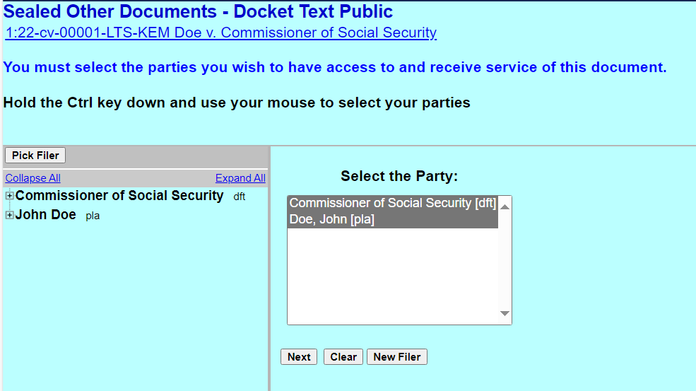

1. The next screen will ask if you want to link this entry to another document filed in this case. You must link this entry to the last day of trial minute entry.

* Put a check in the box



* Click Next
* The docket will appear on the next screen with the documents you can link to.
  + Find the Minute Entry for the last day of the trial
  + Click the box on the left to select the entry you are linking to
  + Next
  + Next
  + Click Next to finalize your filing

