Audit Assist
The Audit Assist function enables you to perform an immediate check on a document to determine if there are any warnings or errors that could impede processing of the voucher.
There are different errors and/or warnings that display a message when something is incorrect on a document. Once you click Audit Assist on the voucher, if something is incorrect, you receive either an error or warning message. When an error message is displayed, you are not allowed to continue with the voucher until the condition has been changed. When a warning message is displayed, you are allowed to continue with the voucher, but your court may require more information or additional changes before the document is approved.
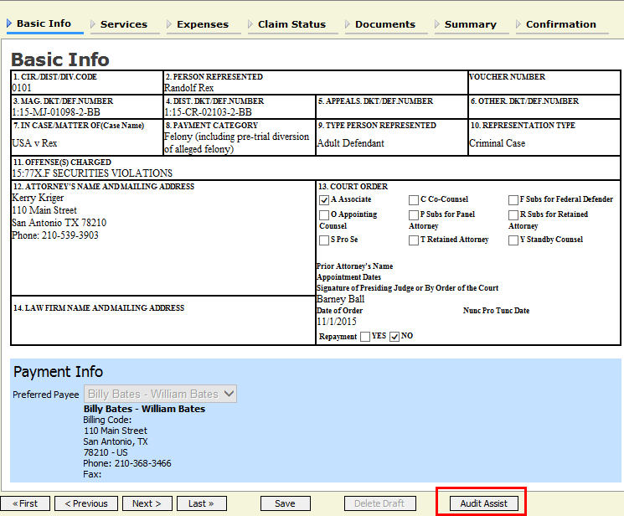
Figure 1: Audit Assist

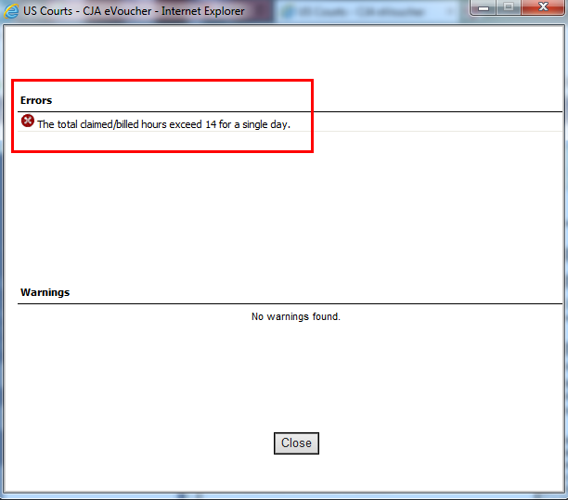
Figure 2: Error Message

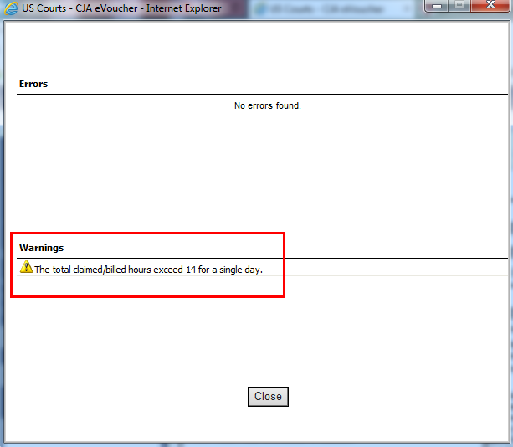
Figure 3: Warning Message

