CJA-24 Authorization of Transcript Request
Step
1
On the Home page, click the case number link in the Appointments’ List folder.
Figure 1: Appointments’ List on Attorney Home Page
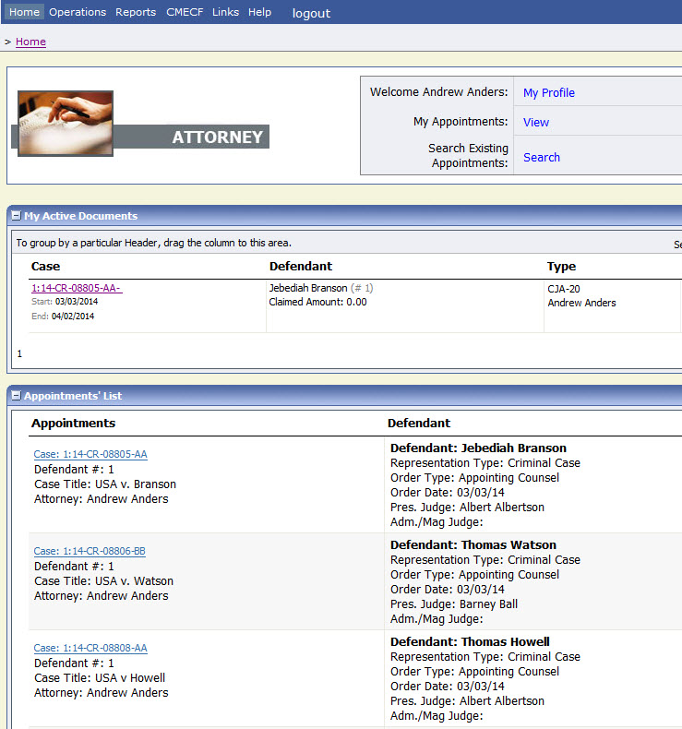
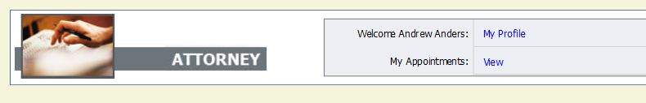

Step
2
On the left side of the Appointment Info page, under Create New Voucher, click the Create link for AUTH-24.

Figure 2: AUTH-24 Create Link on Appointment Info Page
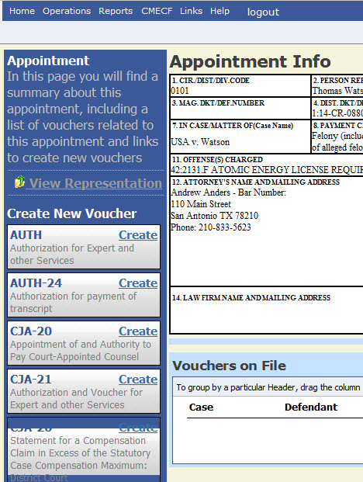

Step
3
On the Basic Info page, enter the required details of the transcript.

Figure 3: Basic Info Page of the CJA-24 Authorization
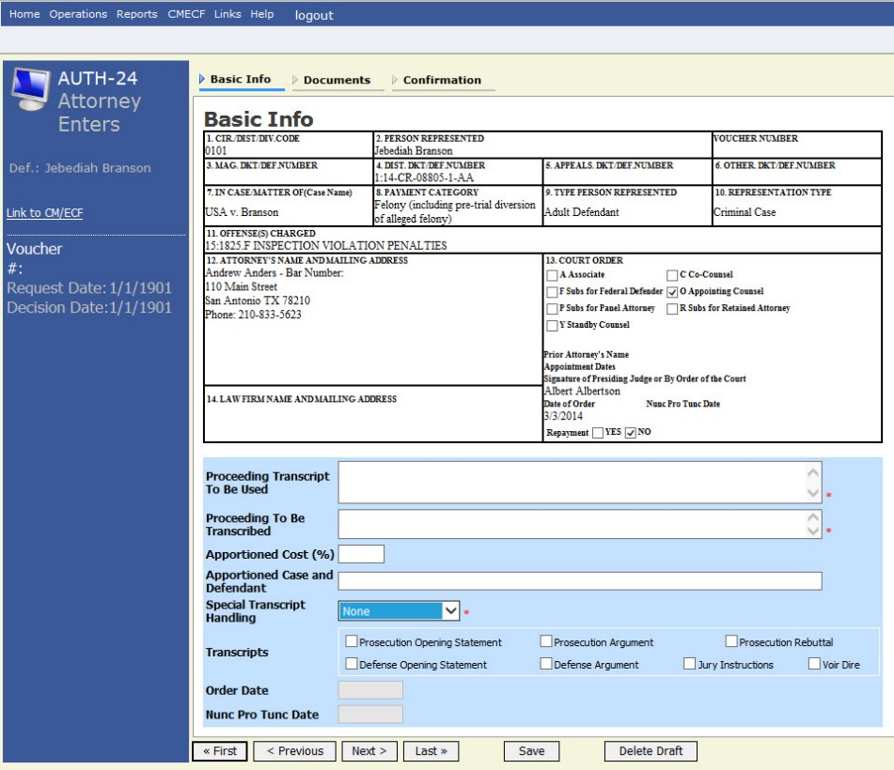

Notes:
- Fill in the details for the transcript you are requesting. The required items are marked with a red asterisk.
- You may attach any relevant supporting documents on the Documents tab.
Select Special Transcript Handling
Choose the type of transcript handling, leave on None, if the other options are not applicable.
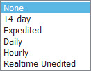
Figure 4: Special Transcript Handling List

Confirm and submit the CJA-24 Authorization.
Step 4
Once you have selected the I swear and affirm the truth or correctness of the above statements check box, the Submit button will become active. Click Submit.
Figure 5: The Submit button on the Confirmation tab.
