Changing Your Username and Password

Your username and password can be accessed in your profile. You will find a My Profile link to your profile near the top of your Home page and can also find a link under the Help menu.
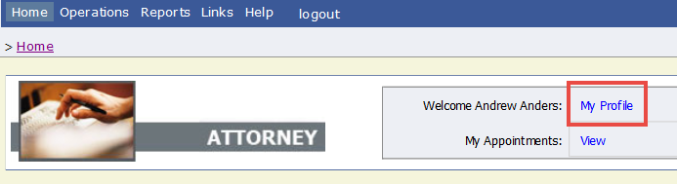
From your My Profile page, click Edit.
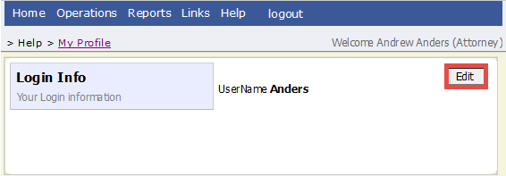
To change your user name, in the Username field, type the new user name, and click change.
To reset your password, click Reset. The screen will change to allow you to enter and confirm the new password. Click Reset again.
