First Login to CJA eVoucher

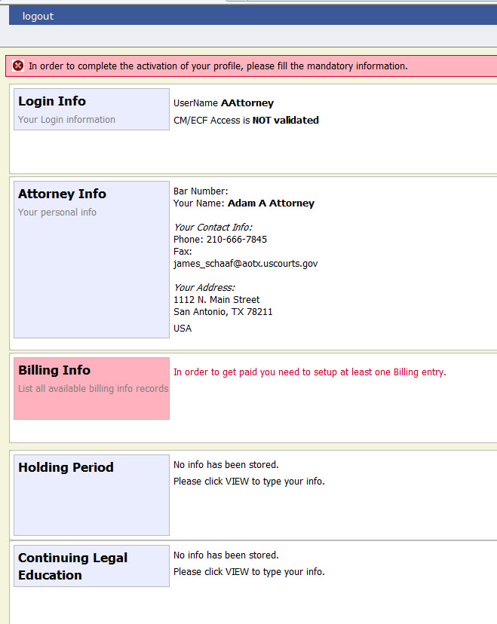
Figure 1: Profile Page
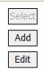
The first time you log on to CJA eVoucher, a screen may appear requesting you to complete your profile information, especially your billing information. Click Add to the right of the Billing Info section. When you have completed any missing information, log out and log on again, and you be taken directly to your Home page. If the profile error page appears again with a new login attempt, check each section for missing information such as phone numbers, Tax ID, etc.

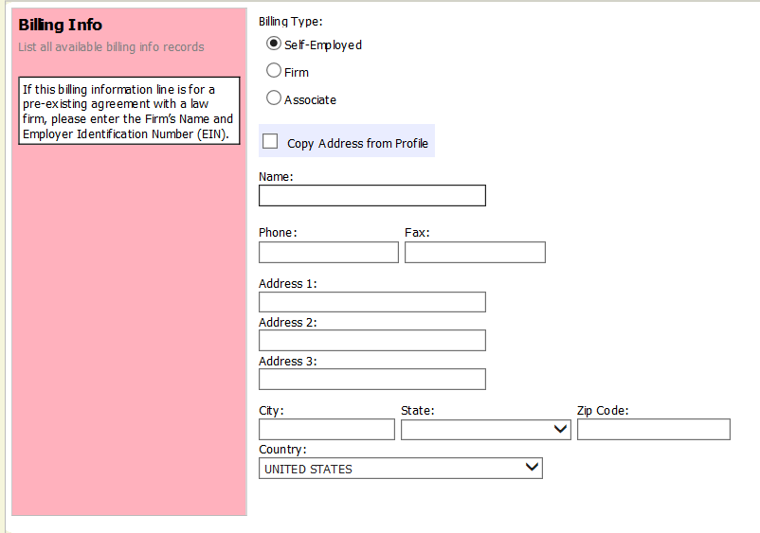
You are required to change your password within 30 days of the first time you log on to eVoucher. Passwords must be at least eight characters in length and contain:

Figure 2: Profile Page- Billing Info section

- One lowercase character.
- One uppercase character.
- One number.
- One special character.
You are required to periodically change your password.

