eVoucher Help Documentation
The Help Documentation feature, also referred to as Robohelp, provides guidance and explanations of the various features and concepts in CJA eVoucher specifically for attorneys and expert service providers. The information contained within the help document is meant to supplement training materials created by individual courts.
For court-specific questions, contact your local district or appeals court.
From the Help menu, select eVoucher Documentation: Attorney and Expert Users.
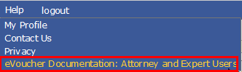
Figure 1: External Help Menu

Topics for external users include basic information on changing user names, resetting passwords, and browser tips; as well as more in-depth information on using the system, such as types of documents, topics specifically for attorney and expert types, and links to other helpful resources. Click any area of interest to view specific details on the topic.
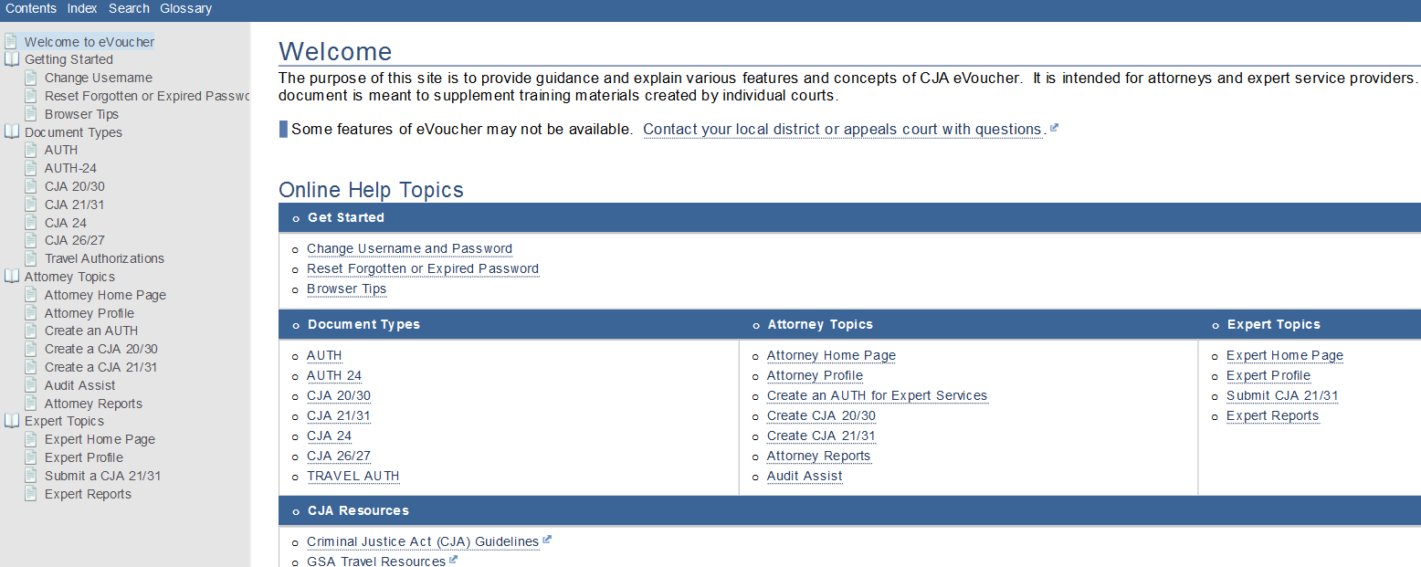
Figure 2: External Help Page

